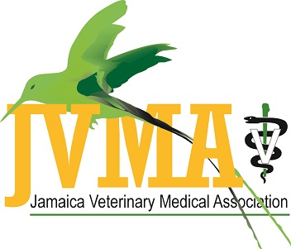
WORLD VETERINARY DAY 2019

MESSAGE FROM THE PRESIDENT OF THE JAMAICA VETERINARY MEDICAL ASSOCIATION

Dr. Nigel Elliott


Once again our local association joins the global community in celebrating World Veterinary Day. A day not limited to the activities planned but a day used to emphasize important aspects of our work as health care givers. This year, the theme acknowledges “The Value of Vaccination”. A noteworthy theme, in view of the current H1N1 circumstance that can affect both the wellness of humans and animals alike:

“Veterinary vaccines have had, and continue to have, a major role in protecting animal health and public health, reducing animal suffering, enabling efficient production of food animals to feed the burgeoning human population, and greatly reducing the need for antibiotics to treat food and companion animals.” - (Center for Food Security and Public Health, College of Veterinary Medicine, Iowa State University, Ames, IA 50011) . The use of vaccines also avoids costly treatments for diseases that can be prevented.

Veterinarians support vaccinations. The judicious use, handling and storage of them can safeguard against the spread of infectious diseases that distresses our patients’ health and happiness. We will do everything to facilitate educating the public on the value of vaccination. So enjoy the day with us, have a good read and be informed through the articles in this supplement that my colleagues have shared.

One Health, One Love.

